November 24, 2020

Dr. Pam Estes Brewer

Mercer MSTCM Program

1501 Mercer University Dr., Macon, GA 31207

Dear All,

Our team has successfully conducted the usability testing of the Mercer MSTCM mobile and desktop websites with four participants for mobile and five participants for desktop. This report includes testing procedures, testing results, pre/post-test surveys completed by each participant, and appendices containing material from testing. Participants completed various tasks on the mobile or desktop MSTCM website. Through careful analysis, our team has identified various issues grouped into categories based on the 5E’s of Usability: effective, efficient, engaging, error tolerant, and easy to learn. This report also contains a number of recommendations to help fix the issues identified, such as

* Copyediting the site
* Integrating the Course Catalog
* Improving headings and organization of information
* Adding information intended to increase the credibility of the program

Overall, the participants were able to complete most tasks and found the website visually appealing. However, we believe that our suggestions will be beneficial to the site, and will improve the user experience. As a team, we assert that solving these issues would yield higher user satisfaction and efficiency within the website. Thank you for this opportunity allowing us to conduct this review on the MSTCM website.

Sincerely,

Cathy Hu and Danielle Levy

Department of Technical Communication

Cathy Hu, Danielle Levy

**MSTCM Website**

**Usability Testing Results Report**

Dr. Pam Estes Brewer

TCO 499

November 3, 2020

# Executive Summary

We are technical communication students, currently participating in the UX Independent Study at Mercer University, who have been tasked to conduct a usability test for the Mercer MSTCM program website. Our team has conducted a usability study of both the mobile and desktop versions of the site in order to test how easily and effectively users could navigate and find information on the website, regardless of the environment/medium of access.

To perform these tests, we enlisted the help of nine participants (four on mobile, five on desktop) to complete a series of eight tasks each. Each of these tasks required performing actions or finding information or files on the MSTCM section of Mercer.edu. During each task, we measured a variety of criteria to determine how well each task could be performed.

We evaluated the results from the tests, which will aid in the recommendation section of the report. Our findings can be separated into categories based on the 5E’s of Usability:

* Effective
* Efficient
* Engaging
* Error Tolerant
* Easy to Learn

Based on the findings, our team recommends priority changes to the website in the following areas:

* Remove or update all dead links.
* Improve understandability using improved headings and a glossary of terms.
* Update the website’s search functionality and accuracy.
* Improve collapsible menu indicators.
* Integrate the course catalog.
* Edit for spelling and grammar.
* Organize the website information by priority of importance.
* Add admission criteria to the FAQ page.
* Remove unnecessary content, and add more credibility related information.
* Improve indicators and identifiers.
* Improve site SEO.
* Add buttons and other navigation tools.

These changes will make the MSTCM website more usable for potential applicants.

**Table of Contents**

Executive Summary iii

Purpose Statement 1

Methodology 1

Test Objectives 1

Data Coding 1

Participants 2

Tasks and Scenarios 4

Evaluation Methods 4

General Protocol 5

Mobile Protocol 5

Desktop Protocol 6

Findings 6

Quantitative Findings 6

Qualitative Findings 9

Effective 11

Efficient 15

Engaging 17

Error Tolerant 17

Easy to Learn 20

Recommendations 21

University Wide 22

MSTCM Specific 25

Appendix A: Moderator Script 28

Appendix B: SUS Survey Results 30

Appendix C: Screener Questionnaire 36

Appendix D: Pre-Test Questionnaire 38

Appendix E: Post-Test Questionnaire (Interview) 39

**Table of Tables**

Table 1 Mobile Participant Characteristics 2

Table 2 Desktop Participant Characteristics 3

Table 3 Number of Pass/Fails Per Task 7

Table 4 Time on Task per Participant for Mobile (*** indicates a failure) 8

Table 5 Time on Task per Participant for Desktop (*** indicates a failure) 9

Table 6 Overview of Findings from the Usability Tests 10

Table 7 Mobile SUS Survey Results 30

Table 8 Desktop SUS Survey Results 33

# Table of Figures

Figure 1 Misspelled "Grievances" on the FAQ page 12

Figure 2 Broken Link on Application Page 12

Figure 3 Resulting Location of the Link Indicated in Figure 2 Above 13

Figure 4 Mobile View of the Course Catalog 13

Figure 5 Blue "School of Engineering" Dropdown Menu 15

Figure 6 Program Director Contact Section 16

Figure 7 Programs Search Bar Yielding No Results With "Program" Search Term 18

Figure 8 Programs Search Bar Yielding Results Without "Program" Search Term 18

Figure 9 "Did you mean: MSTC" Seaarch Recomendation 19

Figure 10 Results of Following the "Did you mean: MSTC" Suggestion 20

Figure 11 Current Menu and Collapsibility Indicators 21

Figure 12 Recommendation for Menu with Subpages Open 22

Figure 13 Example Menu with Arrows 23

Figure 14 Example Menu with Dropdown Indicators on the Left 24

Figure 15 Example Menu with Arrows on the Left (Recommendations 7 and 8 combined) 24

Figure 16 Example Menu with Gray Background 25

Figure 17 Example Contact Section with Direct Link Button 26

Figure 18 Example Contact Section with Direct Link and Meet the Faculty Buttons 26

# Purpose Statement

The goal of this document is to describe the usability study our team conducted on the new MSTCM website. It contains a detailed plan of our study, the results of that study, and our recommendations based on the outcome of the study.

The goal of the test itself was to determine how usable the MSTCM website is. This is especially timely due to the current global pandemic, and its effects on a global shift towards new majors and careers, particularly ones which can be reached in online settings. This test includes efforts to determine how easy the website is to navigate, how efficiently users are able to find key information, and other usability data.

# Methodology

Our team tested four participants on the mobile site and five participants on the desktop site. Sessions took no longer than an hour. During testing, participants were timed in order to gauge how quickly they were able to complete tasks, and whether they were successful. Participants answered a pre-test questionnaire, participated in a post-test interview, and completed a System Usability Scale (SUS questionnaire).

## Test Objectives

The goals of this test were to:

* Determine how participants navigate through the website to complete specific tasks.
* Measure the usability of the features on the MSTCM website.
* Locate problem areas on the MSTCM mobile and desktop websites.

## Data Coding

Our team used four different metrics to determine how usable certain aspects of the MSTCM website were:

1. **Usability Test Success / Failure** - This indicates the number of participants who successfully completed the task and failed the task, respectively. A failures constitute either:
   * An inability to complete a task by participant resignation
   * A claim of completion by the participant without having correctly completed the task
   * A verbal expression of frustration specifically including a declaration of intent to resign under non-testing circumstances
2. **Time to Complete the Task** - This is the average time for all the participants to complete each task.
3. **System Usability Scale (SUS) Questionnaire** - This is a standard usability questionnaire first described by John Brooke in 1986. This scale is designed to quantify the usability of systems to better compare them.

## Participants

We decided to test participants above the age of 21. We chose this age range to reflect the target demographic of the website, which focuses on college undergraduate degree holders with at least one year of professional experience. For the mobile site test, we tried to focus on current and recent Mercer Engineering students. This was in an effort to follow current Mercer and CDC health and safety guidelines by minimizing the risk of exposure across departments, as the mobile site test was conducted in the in-person usability lab located in the Science and Engineering Building on campus. The desktop usability test was conducted remotely with the goal of testing usability for broader and more international audiences. We intended to target participants in India; however, due to a lack of participant interest, we broadened our demographic to include domestic participants as well. Refer to Tables 1 and 2 below.

Table Mobile Participant Characteristics

|  |  |  |  |
| --- | --- | --- | --- |
| Question | | Answer Choices Received | Participant Responses (Out of 4 Participants) |
| 1 | What is your education level? | Some College | 3 |
| Completed undergraduate degree | 1 |
| 2 | How often do you use the internet per week? | 8+ hours | 4* |
| 3 | Have you ever used the Mercer MSTCM program website before? | No | 4 |

Table Desktop Participant Characteristics

|  |  |  |  |
| --- | --- | --- | --- |
| Question | | Answer Choices Received | Participant Responses (Out of 5 Participants) |
| 1 | What is your education level? | High School | 1 |
| Some College | 2 |
| Completed undergraduate degree | 1 |
| Other | 1 |
| 2 | How often do you use the internet per week? | 8+ hours | 5* |
| 3 | Have you ever used the Mercer MSTCM program website before? | No | 5 |
| 4 | Where do you currently reside? | California, USA | 4 |
| India | 1 |

*Initially we had intended to gain information about the participants' proficiency with technology and the internet by asking about weekly internet usage. Unfortunately, all participants answered the same way (8+ hours per week), and we gained little insight from this information. Quantitatively, participant pass/fail rates and average times of completion varied widely (see Tables 3, 4 and 5 below). Qualitatively, our team noticed significant differences in comfort level, ease of use, and general proficiency between participants. Those qualitative observations coincided with some quantitative data regarding participants who accurately completed more tasks in a shorter average time; however, due to the lack of quantifiable auxiliary information from key participants, we are unable to draw definitive conclusions from the data gathered.

## Tasks and Scenarios

The tasks and scenario were based on what information potential future applicants are expected to search for in the contexts in which the site is most likely to be used. Users began the test at the Mercer.edu homepage. If they became lost, they would start the next task at the MSTCM homepage.

The scenario was the following: Imagine you are a college graduate with one year of professional experience looking to gain a master’s degree in technical communication.

Participants were then asked to complete the following tasks:

1. Find out if there are any remote masters programs at Mercer.
2. Find the technical communication program website.
3. Find the profile of the professor in charge of the MSTCM program and name one of their specialized areas of study.
4. List two examples of acceptable undergraduate degrees to be accepted into the program.
5. Find how frequently classes meet.
6. Find how many courses are generally taught each term.
7. Find if the program offers a course in International Technical Communication.
8. Find how much the program costs.

## Evaluation Methods

Our team used multiple instruments to collect quantitative and qualitative data. The assessment methods included:

* **Pre-Test Questionnaire** - This gave an understanding of the users’ proficiency with computers/internet websites as well as their previous use of informational college websites. Our team decided to use a pre-test questionnaire to evaluate our participants’ proficiency with computers, the internet, and graduate program informational websites.
* **Usability Testing (real users performing authentic tasks)** – In order to test the website.
  + Think Aloud Protocol - This assessed the user experience during testing by allowing participants to verbalize their actions and thoughts.
  + Measuring the number of pass/fails for each task - This assessed the effectiveness of the website in providing the necessary information.
  + Measuring the time for task completion - This assessed efficiency by determining how quickly users were able to complete tasks.
* **Post-Test Interview** - This allowed the participant to give personal feedback about their experience. The post-test interview was used to gather more qualitative data about the website. From experience, members of our group have found qualitative data gathered systematically to be helpful in determining what users think needs to be fixed. The post-test interview questions can be seen in Appendix E.
* **System Usability Scale** - This scale was designed by and when to quantify the usability of systems to better compare them. This scale is designed to quantify the usability of systems to better compare them. This was chosen because it is a standardized metric that is used often in usability testing. Additionally, it allows for the comparison of multiple systems being tested.

## General Protocol

The general protocols for both the mobile and desktop tests were very similar; however, there were some differences due to the testing environments. The pre-test questionnaire, scenario and tasks, moderator script, post-test interview, SUS, and data capture were all the same. However, the difference came in the test environment itself, as well as certain reasons regarding the importance of the pre-test questionnaire when evaluating the user demographics in the desktop test.

### Mobile Protocol

The team asked pre-test questions, utilized a document camera and Zoom to capture usability tests, conducted a post-test interview (Appendix E), and an SUS evaluation (Appendix B). The test itself was conducted in-person in the Usability lab on campus. While Zoom was utilized to capture and record participants’ answers to the SUS and interview questions, the actual mobile test was conducted on a standardized iPhone XS and captured using the in-lab document camera. The document camera was screen shared over Zoom, and the Zoom screen recording captured that footage.

When a participant began testing, the moderator read from the script, and provided tasks to the participant throughout the testing process (Appendix A). First, a pre-test questionnaire was already pulled up on the lab computer in the form of a Google Form. After the participant completed the questionnaire, the moderator introduced the participant to usability testing and gave the participant tasks to complete. Once the tasks were complete, the moderator then asked the post-test interview questions which were captured on Zoom. The testing concluded after the participant filled out the SUS survey (also as a Google Form).

### Desktop Protocol

The team asked pre-test questions, utilized Zoom when capturing testing, and conducted a post-test interview (Appendix E) and SUS Evaluation (Appendix B).

When a participant began testing, the moderator read from the script, and provided tasks to the participant throughout the testing process (Appendix A). First, a pre-test questionnaire was sent through Zoom in the form of a Google Form. After the participant completed the questionnaire, the moderator began explaining the tasks. Once the tasks were complete, the moderator then asked the post-test interview questions. The testing was completed by the participant filling out the SUS survey (also as a Google Form).

# Findings

The results of the tests include the pass/fail values (see Table 3), time elapsed values (see Tables 4 and 5), and SUS scores. Additionally, this section also includes the qualitative findings based on what our participants noticed or struggled with during the course of each test. These qualitative findings have been summarized in Table 6 below. Our findings can be separated into categories based on the 5E’s of Usability: Effective, Efficient, Engaging, Error Tolerant, and Easy to Learn.

## Quantitative Findings

This section details the quantitative data gathered from the usability study. In the three subsections below, we evaluated and interpreted the numerical data for such indicators as pass/fail rates, time for completion, and SUS scores. We have drawn attention to the most important indicators in this section and have referenced that information in the qualitative findings below to explain how the data reflects the usability of the site.

Pass/Fail

Table 3 below details the pass/fail rates of each task. The task which generated the most failures for the mobile site was task 7, searching for course descriptions (four out of four failures), while the task which generated the most failures for the desktop test was task 4, searching for admission criteria (four out of five failures). Overall, the task which generated the most failures was task four with a combined seven failures out of nine participants. The task which generated the least amount of failures for mobile, desktop and combined was task 2, finding the MSTCM website from the Mercer.edu home page. All nine participants were able to successfully complete this task.

Table Number of Pass/Fails Per Task

|  |  |  |  |  |  |  |
| --- | --- | --- | --- | --- | --- | --- |
| Task | Mobile | | Desktop | | Combined | |
| Pass | Fail | Pass | Fail | Pass | Fail |
| 1 Find Remote Masters Programs | 2 | 2 | 3 | 2 | 5 | 4 |
| 2 Find MSTCM Website | 4 | 0 | 5 | 0 | 9 | 0 |
| 3 Find Professor’s Specialization | 3 | 1 | 2 | 3 | 5 | 4 |
| 4 Find Admission Criteria | 1 | 3 | 1 | 4 | 2 | 7 |
| 5 Find Class Meeting Frequency | 2 | 2 | 3 | 2 | 5 | 4 |
| 6 Find Classes Taught Each Term | 1 | 3 | 2 | 3 | 3 | 6 |
| 7 Find Course Description | 0 | 4 | 3 | 2 | 3 | 6 |
| 8 Find Program Cost | 2 | 2 | 3 | 2 | 5 | 4 |
| Total | 15 | 17 | 22 | 18 | 37 | 35 |
| Total Administered Tasks | 32 | | 40 | | 72 | |

Just under half of the total administered tasks were either left uncompleted or were completed incorrectly by participants. Out of 72 total administered tasks, 35 were failures. In particular, 17 out of the 32 total administered tasks on mobile were failures, as opposed to only 18 out of the total 40 administered tasks on desktop. This is a strong indicator that neither version of the site (but particularly the mobile site) is a helpful marketing tool for the university or the MSTCM program. If potential applicants are unable to find the proper information on the website, they are less likely to apply to the program or the University at large. The number of tasks which were considered “failures” is visually demonstrated best in Tables 4 and 5 below.

Time for Completion

Tables 4 and 5 below detail the time taken to complete each task. The task which took the longest average time for mobile participants to complete was task 4, searching for admission criteria, with a time of 3:20 from the one participant who was able to complete the task. It is important to note that all mobile participants failed task 7, searching for course descriptions.. The shortest time for mobile was task 6, finding the number of classes taught each term, which took the one participant who was able to complete the task 16 seconds to complete. It is important to note that that participant demonstrated the shortest completion times for all of the tasks except for one, and qualitatively demonstrated the highest technology proficiency out of all participants. That participant also had the shortest average task completion, and shortest overall test out of any participant in the entire mobile/desktop combined study. Unfortunately, for the reasons outlined in the participants’ section above, we can only make speculations and cannot accurately conclude what the reasons for these discrepancies may be.

Table Time on Task per Participant for Mobile (*** indicates a failure)

|  |  |  |  |  |  |
| --- | --- | --- | --- | --- | --- |
| Task No. | P1 | P2 | P3 | P4 | Average |
| 1 | 1:11 | *** | *** | 2:10 | 1:41 |
| 2 | 1:15 | 1:03 | 1:22 | 1:11 | 1:13 |
| 3 | 0:57 | *** | 0:43 | 1:01 | 0:54 |
| 4 | 3:20 | *** | *** | *** | 3:20 |
| 5 | 0:57 | *** | 2:42 | *** | 1:50 |
| 6 | *** | *** | 0:16 | *** | 0:16 |
| 7 | *** | *** | *** | *** | *** |
| 8 | 0:54 | *** | 1:08 | 0:26 | 0:49 |

The task which took the longest average time for desktop participants to complete was task 5, class meeting frequency, with an average time of almost three minutes. The shortest average time for desktop was task 4, admission criteria, which took an average of 40 seconds to complete.

Table Time on Task per Participant for Desktop (*** indicates a failure)

|  |  |  |  |  |  |  |
| --- | --- | --- | --- | --- | --- | --- |
| Task No. | P1 | P2 | P3 | P4 | P5 | Average |
| 1 | 1:48 | *** | 1:03 | *** | 0:39 | 1:10 |
| 2 | 1:12 | 1:09 | 0:27 | 1:47 | 0:45 | 1:04 |
| 3 | *** | *** | *** | 1:21 | 0:50 | 2:11 |
| 4 | *** | *** | *** | *** | 0:40 | 0:40 |
| 5 | *** | 7:37 | 0:27 | *** | 0:19 | 2:48 |
| 6 | *** | 4:39 | *** | 0:38 | *** | 2:38 |
| 7 | *** | 0:56 | *** | 3:41 | 0:19 | 1:39 |
| 8 | *** | *** | 0:56 | 0:31 | 0:15 | 1:42 |

System Usability Scale

The SUS evaluation revealed a score of 65 for the mobile site and a score of 79.4 for the desktop site. A score of 68 indicates that the website has an average level of usability, meaning that the mobile site has a less than average level of usability, and the desktop site has a higher than average level of usability. The full breakdown of SUS scores can be found in Appendix B.

## Qualitative Findings

This section details the qualitative findings which made noticeable impact on the participants’ interaction with the website. These qualitative findings include details observed by our team as well as details either verbalized or explicitly noticed by participants during testing. They have been separated into categories based on the 5E’s of Usability: Effective, Efficient, Engaging, Error Tolerant, and Easy to Learn. These findings will be the basis for our recommendations. A summary of the findings can be found organized in Table 6 below, promptly followed by the full explanations.

Table Overview of Findings from the Usability Tests

|  |  |  |  |  |
| --- | --- | --- | --- | --- |
| Category | Problem Identified | Description | # Mobile Participants Affected | # Desktop Participants Affected |
| Effective | Editing | Spelling errors. | 0 out of 4 | 0 out of 5 |
| Broken Links | Various links were dead links (did not lead anywhere). | 0 out of 4 | 1 out of 5 |
| Mobile Course Catalog | Mobile course catalog is unusable. | 4 out of 4 | N/A |
| International Terminology | Terminology used on the site is not universal. | 0 out of 4 | 1 out of 5 |
| Credentials and Accolades | No auxiliary information indicating credibility of the program. | 1 out of 4 | 2 out of 5 |
| Headings | Headings not optimal indication of section content. | 1 out of 4 | 2 out of 5 |
| Menus | Redundant/extraneous menus and extensive levels of collapsible options. | 1 out of 4 | 4 out of 5 |
| Efficient | Content Quantity | Too many words/too much “fluff” content (especially on main page) | 2 out of 4 | 3 out of 5 |
| Content Organization | Pertinent information is too low on the page and the information is not organized in a conducive way. | 2 out of 4 | 3 out of 5 |
| Meet the Faculty | No link directly to Dr. Brewer's profile page. | 2 out of 4 | 3 out of 5 |
| Improve SEO | General SEO improvement is always beneficial for program and University marketing purposes. | 0 out of 4 | 0 out of 5 |
| Engaging | Design and Aesthetics | General design of the website is well done. | 2 out of 4 | 3 out of 5 |
| Desktop Course Catalog | Not well integrated, inconsistent design compared to the rest of the website. | N/A | 3 out of 5 |
| Error Tolerant | “Programs” Search Bar | Does not properly filter extraneous words searched by users. | 0 out of 4 | 2 out of 5 |
| Search Correction | Unnecessary/incorrect search correction prompts. | 0 out of 4 | 1 out of 5 |
| Easy to Learn | Collapsible Menu | Insufficient indicators of collapse menu features. | 0 out of 4 | 4 out of 5 |
| Application | Insufficient indication of use of general engineering application rather than an MSTCM specific application. | 0 out of 4 | 3 out of 5 |

### 

### Effective

This section describes our recommended changes to the effectiveness of the website. These changes often deal with features which either do not work, require editing, or do not accomplish the goals of the website (i.e. to inform users about the MSTCM program and encourage them to apply for the program).

*Editing*

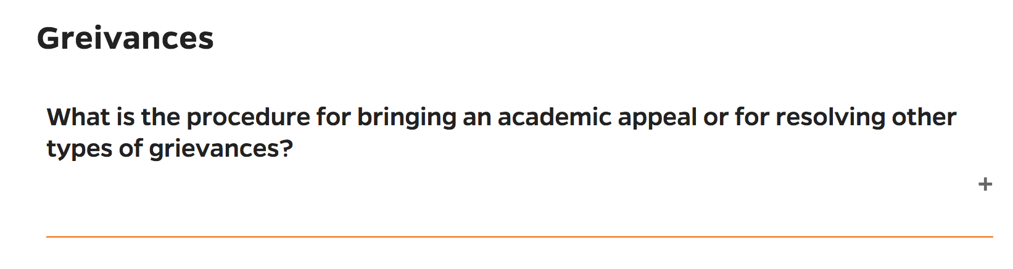The word “grievances” is misspelled on the FAQ page. Spelling errors decrease credibility, which decreases the effectiveness of the program website as a marketing tool for the University and the MSTCM Program.

Figure Misspelled "Grievances" on the FAQ page

*Broken Links*

While conducting a usability test, our participant discovered that there were some dead links on the site which led to a “404 Error” page as seen in Figure 3 below. Specifically the “learn more about admission categories page” link on the School of Engineering Graduate Program “Apply Now” page, seen in Figure 2 below. This was found during a desktop site test; however, when double checked it is also broken on the mobile site. These dead links can become frustrating and confusing for users.

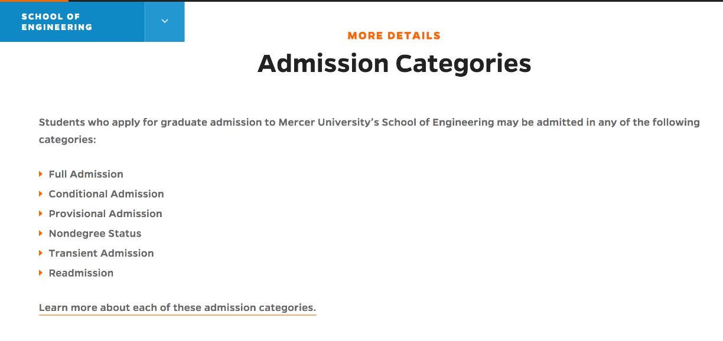

Figure Broken Link on Application Page

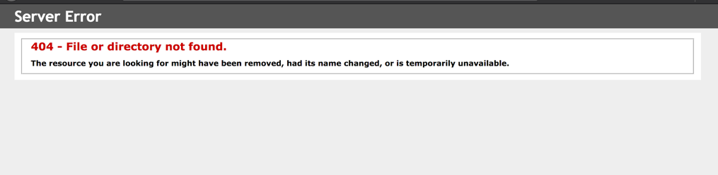

Figure Resulting Location of the Link Indicated in Figure 2 Above

*Mobile Course Catalog*

As demonstrated in Table 3 above, all four mobile participants were unable to access the course catalog because it is not properly integrated into the rest of the site and is incompatible with mobile website operation, as seen in Figure 4 below. When participants attempted to look over the course catalog page, participants have said, “I assume [course descriptions are on the catalog site but I can’t read it on the mobile version,” “this page is unusable,” and how “everything is very to one side of the scene. I’m hoping you’re seeing that this is useless.”

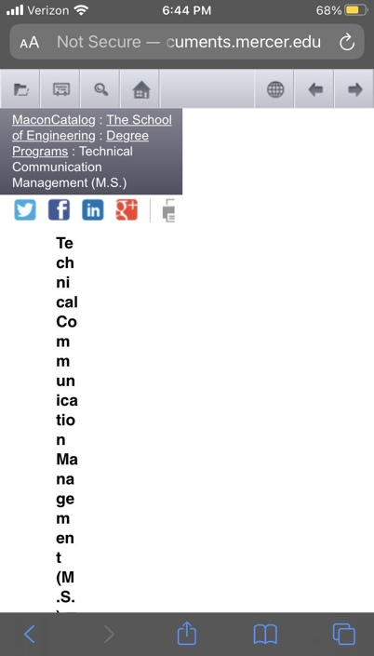One participant even accessed another program’s website (software engineering) to attempt to access the course catalog through that site, but was unsuccessful. This information is imperative to potential applicants because it allows them to assess if the program is a proper fit for them.

Figure Mobile View of the Course Catalog

*International Terminology*

During the desktop test, we had one participant from India, as it was expressed that the program intends to expand marketing in that region. This participant expressed confusion over the terminology used on the site to refer to specific parts of the program, and she said, “I didn’t follow instructions correctly because I was not aligned with the terms used.” This included terms such as undergraduate vs graduate vs postgraduate, course vs class vs curriculum vs subject, program vs course, etc. She had specifically stated that she felt that any potential applicant would have done research to understand the terminology used by the program, and therefore would not have a problem with the terminology. We intended to verify this theory by testing another Indian participant; however, we were unable to due to a schedule cancellation by a second Indian participant and the fact that there was no other interest from international participants. It is important to note that Indian higher education uses similar terminology to European higher education, which is another region where many MSTCM applicants live. Any changes which can increase user understanding of information will help improve the user experience and marketing ability of the website among target audiences.

*Credentials and Accolades*

There was a distinct lack of relevant information which added to the credibility of the MSTCM Program. There were only two statistics about the program and while there are some alumni testimonials, there is no mention of projects, accolades, or current research relating to current or former students and faculty members. Several participants indicated on the pre-test questionnaire that they expected to be able to find this information on the website. These pieces of information significantly increase the credibility of a program, and by not having them, the website is not an effective marketing tool for the University or the MSTCM Program.

*Headings*

Some headings were not effective in indicating what content was contained within those sections. Specifically, the “Program Requirements” section currently includes graduation requirements; however, a number of participants navigated there to look for acceptance requirements. Additionally, the acceptance criteria is listed under “Apply Now” and this section does not include actual application information. Sub-standard headers decrease the usefulness of the website by making information more difficult for users to find, which can be frustrating.

*Menus*

The sidebar menu is quite long and many participants did not realize that there were further collapsed menu options which needed to be used to navigate the rest of the site. Additionally, the blue menu depicted in Figure 5 below is a copy of the sidebar menu, but with fewer levels of collapsible options. While most participants either didn’t see or ignored that blue menu, the ones who did attempt to use it either ended up lost in the website and unable to complete tasks, or were under the impression that where the blue menu stopped opening further collapsed options, so did the sidebar menu. Finally, the blue menu uses arrows and then plus signs to indicate a collapsible menu, which is inconsistent with the exclusive use of plus signs in the sidebar menu. These factors made it very difficult for users to navigate around the site and find necessary information, which became frustrating for participants.

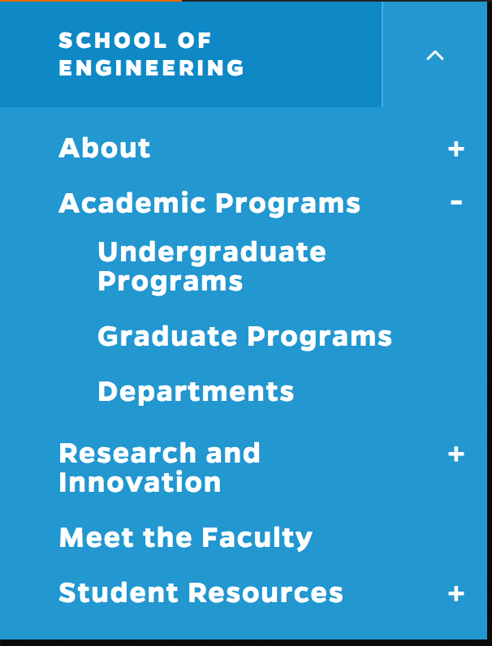

Figure Blue "School of Engineering" Dropdown Menu

### Efficient

This category details features which diminished user experience. These elements of the website design often made it difficult for participants to find important or relevant information quickly and efficiently. Not having information readily available to access can become frustrating and confusing for users, which means the website is not an efficient marketing tool for the University or the MSTCM Program.

*Content Quantity*

There was too much content throughout the website, particularly paragraph chunks. This means the website was not effective for “skimming” through the information. Due to the quantity of information (particularly irrelevant or “fluff” content), the pertinent information was not readily accessible to users. By not having that information accentuated, the website is not an efficient marketing tool for the University or the MSTCM Program.

*Content Organization*

Certain important information is poorly located on the current website. Oftentimes it is too low on the page or does not stand out enough. Specifically, the section which details admission requirements is located below some of the program details and graduation requirements. Unfortunately, participants failed the task associated with finding this information most out of all the tasks throughout both the mobile and desktop test combined, with seven out of the nine participants failing the task (see Table 3 above). This information is imperative to potential applicants because it allows them to assess if the program is a proper fit for them.

*Meet The Faculty*

Approximately half of our participants were unable to correctly identify the professor in charge of the MSTCM program. Out of the five participants who successfully completed the task, several of them (particularly on desktop) expressed dissatisfaction in the fact that there was not a button linked directly to Dr. Brewer’s profile page from the contact section which lists Dr. Brewer as the Director of the MSTCM program (see Figure 6 below).

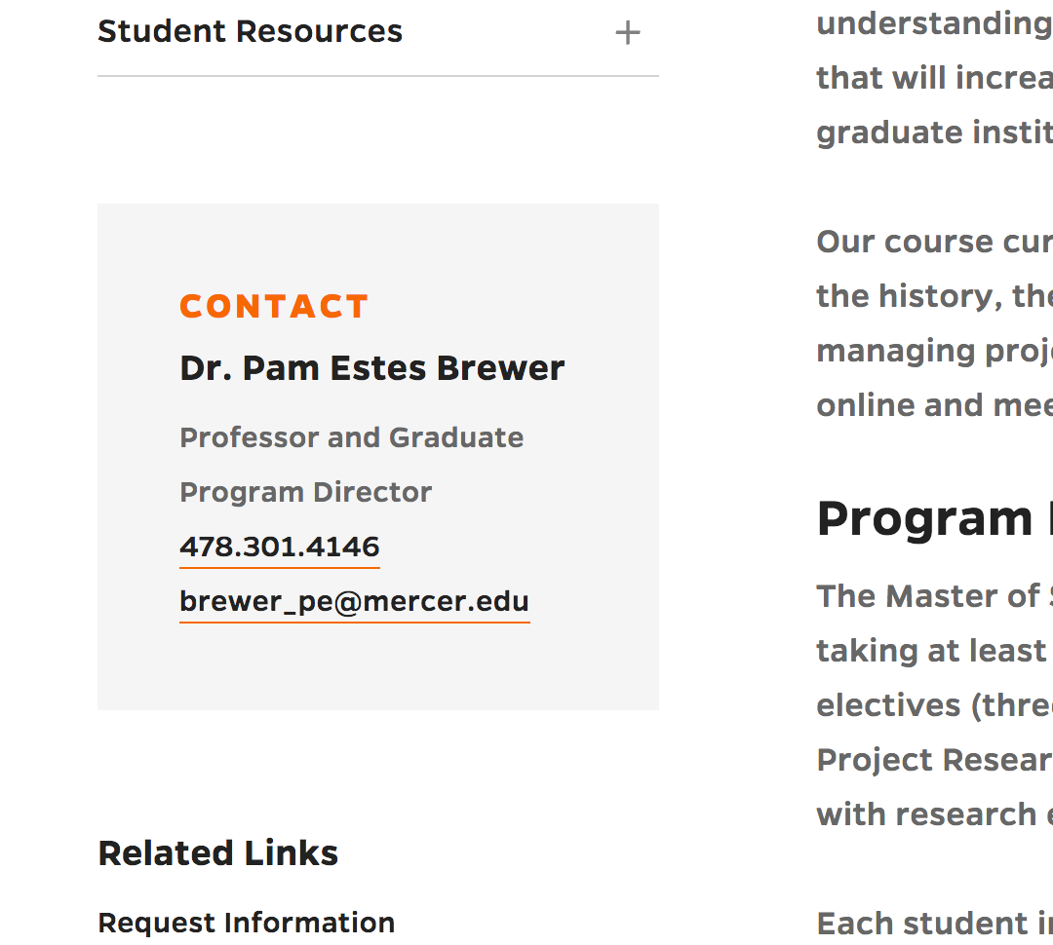

Figure Program Director Contact Section

*Improve SEO*

The website has sufficient SEO for terms such as “MSTCM,” (top result) “MS in technical communication,” (first page) and “master’s in communication management” (first page). However, due to the inconsistency of naming across the field and similar programs, we feel it is important to take other potential search options into account which may indicate an interest in MSTCM or similar programs. Some of these search terms include “MS in communication management” and “master’s in communication.”

### Engaging

This section indicates factors which influence user’s willingness to use and remain on the website. Often times these factors discuss design, aesthetics, integration and appearance of the elements

*Design and Aesthetics*

Several of our participants, particularly during the desktop test, expressed that they thought the aesthetics, “visuals, and UI design” of the entire website were well done and looked consistent and professional. They also complimented the fact that the colors were “soothing,” and that styles were easy to read and not distracting in any way.

*Desktop Course Catalog*

Several of our desktop participants expressed a disinclination towards the lack of integration between the Course Catalog and the rest of the website. Several of them indicated that they were confused, overwhelmed, thought they were in the wrong place and off-put by the abrupt change in design. The catalog is imperative to potential applicants because it allows them to assess if the program is a proper fit for them, and by not having it properly integrated it can create an inconsistent perception of University branding, which discourages them from applying, especially considering the relevant industry places heavy emphasis on attention to detail, particularly in areas such as design and information transfer.

### Error Tolerant

This section details features and factors relating to the website’s tolerance of user error. The ideal website, from a usability standpoint, would be able to identify and correct human error, often without the user even being notified that a correction occurred. In cases where that is not possible, the ideal website would have features which allow users to easily correct errors themselves.

*“Programs” Search Bar*

Under the “Programs” tab on the general Mercer.edu website, participants expressed frustration with the search feature. It was expected that the search bar would take every searched phrase into consideration, but this was not the case. For example, “program” is not in any of the results, but is a common word that participants used in their search. This word automatically led to zero search results (see Figures 7 and 8 below), despite it being a common word used by participants when searching for a program.

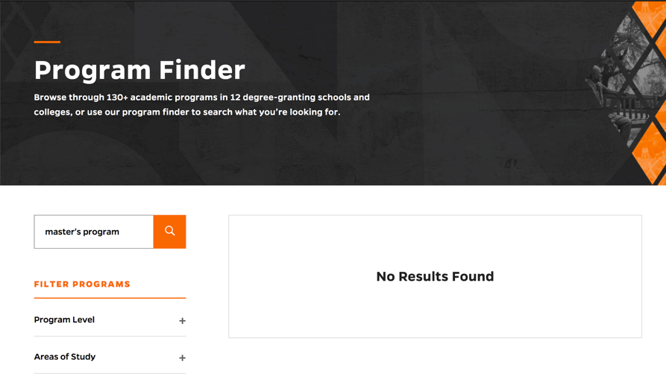

Figure Programs Search Bar Yielding No Results With "Program" Search Term

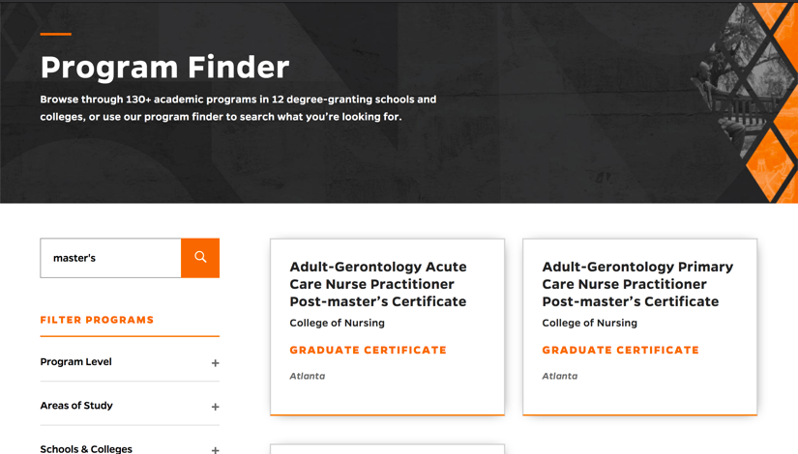

Figure Programs Search Bar Yielding Results Without "Program" Search Term

*Search Correction*

One of our desktop participants used the university search feature to access the MSTCM webpage from the Mercer.edu home page. After she typed “MSTCM” into the search bar, a “did you mean:” correction gave her the option of searching for “MSTC” instead. Because she was unfamiliar with the program, she accepted the search recommendation and was redirected to a search page with zero results. This frustrated her because a prompt to search for a different variation in keywords implies that the user has typed or searched incorrectly, however in this situation she was correct and the prompt was a faulty search.

This creates confusion for users and adds points of error which are unnecessary and diminishes user experience. It is important to note that the user was international (India) and none of the domestic participants experienced this, nor was our team able to recreate the phenomenon, which can be seen in Figures 9 and 10 below.

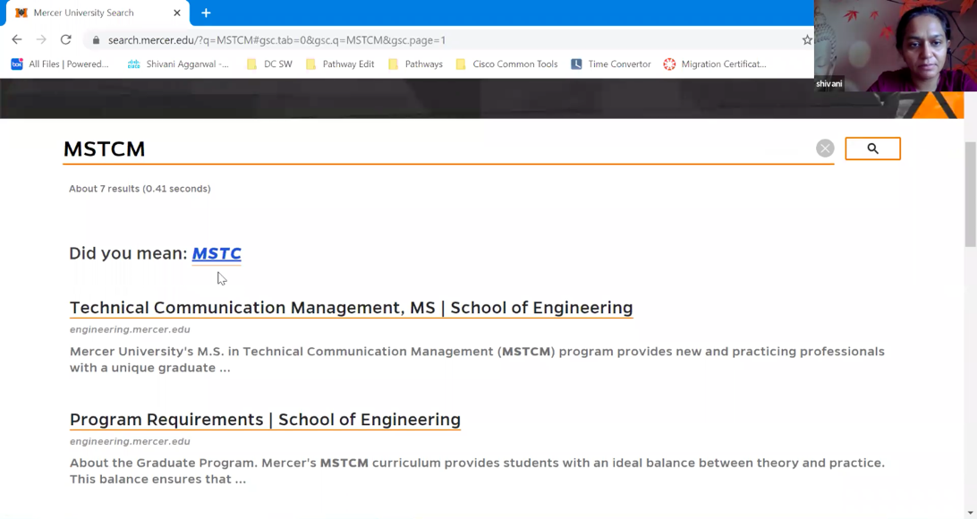

Figure "Did you mean: MSTC" Seaarch Recomendation

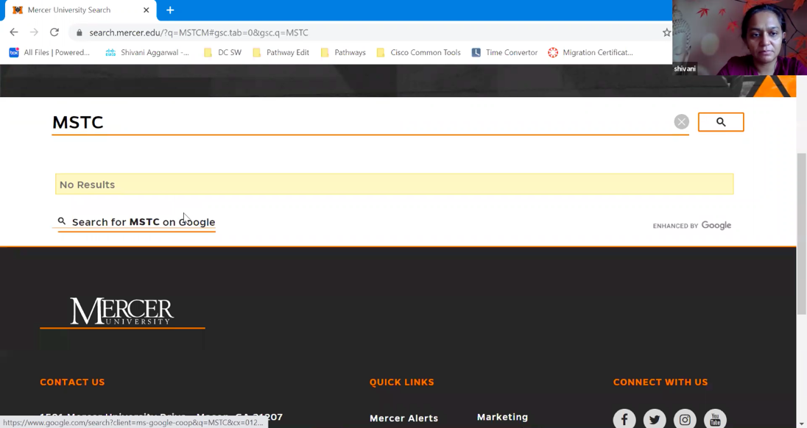

Figure Results of Following the "Did you mean: MSTC" Suggestion

### Easy to Learn

This category indicates factors which relate to the ease of which users are able to identify, learn and use tools and features on the site. If important features are hard to use or functions cannot be identified, users struggle to navigate and take advantage of important functionality of the website, which creates confusion and frustration for users.

*Collapsible Menu*

This feature caused the most problems for our desktop users. Several of our participants were unable to identify the collapse menu feature, or struggled to recognize that the collapsible menu could open further. Because of this, several participants were unable to complete multiple tasks, indicating that users would be unable to find important information about the program. Upon clicking the plus sign to open the collapsible menu (indicated in Figure 11 below), one participant said, “I didn’t know that dropdown was there.”

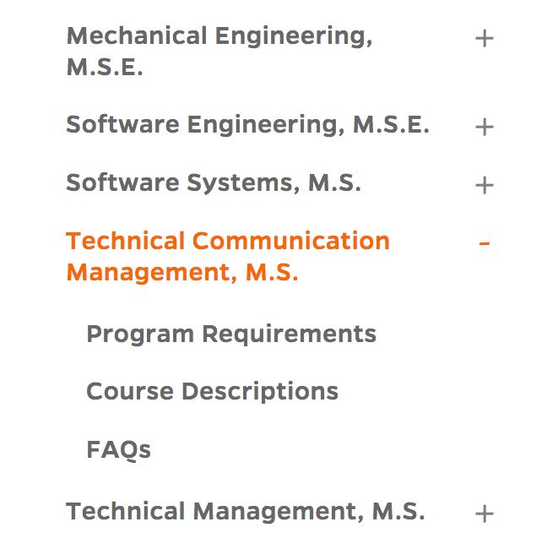

#### 

Figure Current Menu and Collapsibility Indicators

*Application*

Several participants expressed confusion regarding the general engineering graduate program application. Participants often selected the “Apply Now” button when looking for admission requirements, and often didn’t realize that the application page was for general engineering, rather than being specific to MSTCM. There is a note under the “Apply Now” header on the MSTCM webpage which indicates to use the general engineering graduate application, however due to the fact that admission requirements are also included in that section and the information is so low on the page, that indicator was frequently missed by participants. Overall the entire task regarding admission criteria was confusing and frustrating for multiple participants.

# Recommendations

Based on the findings presented above, we believe that the following actions would increase the overall usability of the MSTCM Program website. They have been separated into recommendations which affect the usability of the entire Mercer.edu website and those which only affect the MSTCM webpage specifically. Additionally, they have been numbered by priority.

## University Wide

These are recommendations which can be applied to the broader Mercer.edu website.

1. Edit the site for spelling and grammatical mistakes.
   * Editing mistakes can diminish the credibility of the program.
2. Remove or update all dead links.
   * Deleting or updating such links prevent user confusion or frustration.
3. Develop an integrated course catalog, such as directly adding the information to the webpages.
   * Integrating the catalog would improve usability on desktop and make it accessible on mobile, both of which would prevent confusion and frustration for users.
4. Begin with all relevant levels of the sidebar menu promptly when the user enters the site.
   * Currently the menu is only opened as far as the page the user is currently on, but it is recommended that the menu start with all relevant subpage menu options open as seen in Figure 12 below.

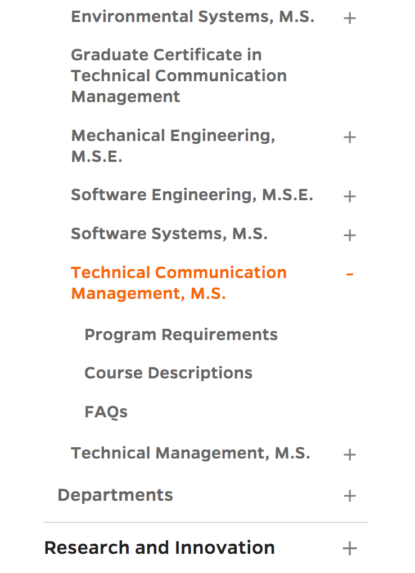

Figure Recommendation for Menu with Subpages Open

* + This will indicate to users that those page options are available, rather than allowing them to be hidden within the collapsed menu, as was shown during the study. Having more obvious menu options makes navigation easier and less confusing for users.

1. Improve the “Programs” search bar ability to filter irrelevant words while still providing relevant results.
   * This will allow users to find relevant programs more easily.
2. Improve accuracy of recommended and “did you mean” search prompts.
   * This will prevent confusion and frustration for users.
3. Change collapsible menu indicators from plus signs to arrows, such as in Figure 13 below.
   * 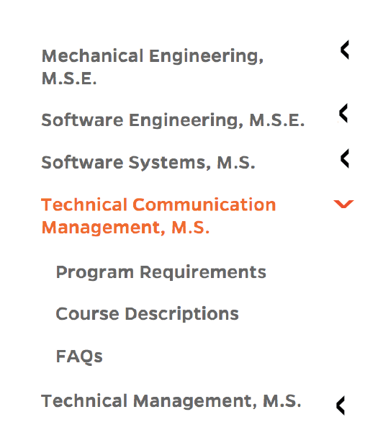This is a more universal indicator that there is a collapsible menu that can be opened.

Figure Example Menu with Arrows

1. Move the collapsible menu indicators to the left side of the words, rather than the right, such as in Figure 14 below. A combination of this and the recommendation 7 can be seen in Figure 15 below.
   * When navigating websites user’s eyes move in an “F” pattern, so for a menu they usually stop searching to the right when they reach the end of the word or phrase, which means that they are much more likely to notice collapsible menu indicators located to the left of the words on the menu.

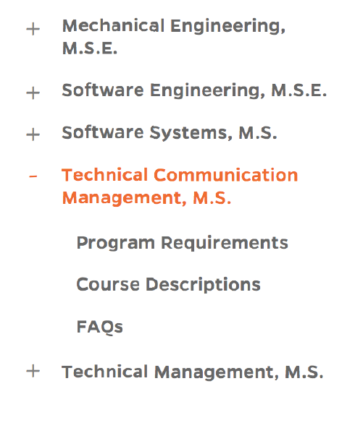

Figure Example Menu with Dropdown Indicators on the Left

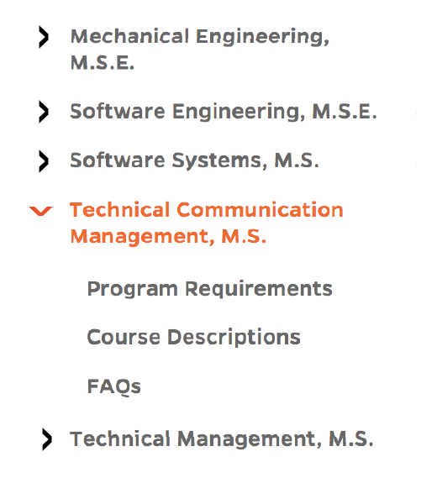

Figure Example Menu with Arrows on the Left (Recommendations 7 and 8 combined)

1. Use colored background to accentuate subpages on the menu, such as in Figure 16 below.
   * This will help the relevant subpages stand out, making the menu easier to navigate and the website as a whole more useful for users.

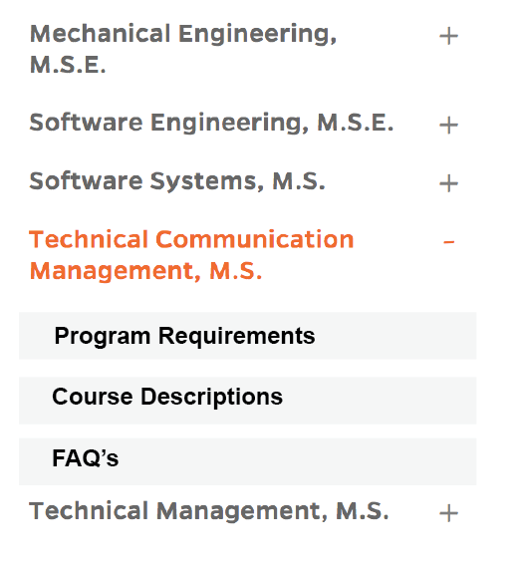

Figure Example Menu with Gray Background

1. Remove the blue menu shown in Figure 5 above.
   * This menu is redundant and unused by most users.
   * The few users who found this menu can become confused by the fact that it does not have as many collapsed levels as the main sidebar menu.

## MSTCM Specific

These are recommendations which either primarily or exclusively apply to the MSTCM webpage.

1. Make headings more accurate and better descriptors of the relevant content. We specifically recommend changing “Program Requirements” to “Graduation Requirements” or “Program Curriculum” and changing “Apply Now” to “Admission Requirements.”
   * This will decrease ambiguity and make the website less confusing for users.
2. Make sure information is grouped appropriately under headings, such as separating the information which indicates to use the general Engineering Graduate Application to a separate section with the heading “How to Apply.”
   * This will make important information easier to find and less confusing for users.
3. Reorganize the website so that the most important information has priority location at the top of the page. The more relevant and important information is, the closer it should be to the top. For example the benefits of distance learning are currently above admission requirements which is at the bottom of the page. Admission requirements should be significantly closer to the top of the site.
   * This will allow users to find the most important information more quickly, which makes the entire site easier to use.
4. Improve SEO for more possible variations on searches related to the program title and description such as “master’s in communication” or “master’s in communication management.”
   * This will increase awareness of the program in potential applicants searching for similar kinds of programs.
5. Add admission requirement information to the FAQ page.
   * This will make that information (which is extremely important and relevant) more accessible and easier to find.
6. Add clear indicators to the Graduate Admissions application page that it is the general application for graduate engineering programs.
   * This prevents users from becoming confused and assuming they are on a program specific application relevant to whatever program webpage they have just come from.
7. Add a direct link to Dr. Brewer’s profile page next to the “contact” section on the left side of the page. Examples of how this could be accomplished can be seen in Figures 17 and 18 below.
   * This will allow potential applicants to quickly gain important insight into the faculty members they will be working with as a student in the program, particularly the director of the program, Dr. Brewer.

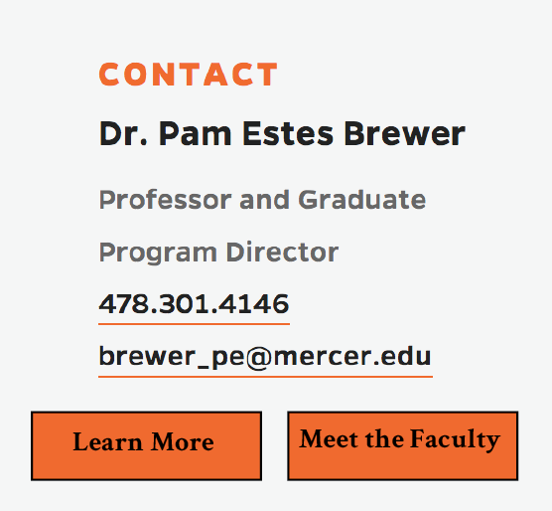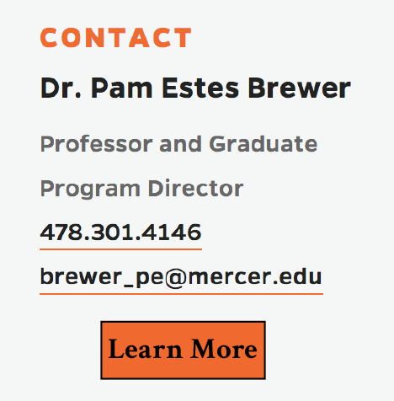

Figure Example Contact Section with Direct Link Button

Figure Example Contact Section with Direct Link and Meet the Faculty Buttons

1. Add credentials and accolades to the site including research, projects and accolades of current and former students and faculty.
   * This increases the credibility of the program which makes it more desirable to potential applicants
2. Create a glossary of terms.
   * By adding a glossary of terms, international users will be able to better understand important elements of the website as well as aspects of the program, which would decrease confusion for those audiences. This is important due to the department’s desire to expand the international reach of the program.
3. Decrease the amount of extraneous words and paragraph chunks, particularly on the main page.
   * This will make finding relevant information easier for users and provide space for program statistics and accolades.

# Appendix A: Moderator Script

**Welcome**

* Welcome to the MSTCM (mobile/desktop) website usability test. Thank you for taking the time to participate in this test. I’m __NAME__ and will be working with you for this test.

**Purpose of the Study**

* The purpose of this study is to observe your use of this website and its functions. Please state your issues anytime you begin struggling with this interface.

**Pre-Test Interview**

* I will be asking you to perform tasks within the website. For accurate results, please use the ‘think aloud’ process. This is accomplished by vocalizing your thought process, even if it seems redundant or self-explanatory. For example, if your task is to return to the home page and you click on the “Home” button to complete the task, then say out loud “I want to return home, so I am clicking the ‘Home’ button”. Additionally, tell me what you like, what you don’t like, what confuses you and why any time you notice something that stands out during the test. I may prompt and remind you to share your thoughts throughout this process.
* When you feel you have completed the task to the best of your ability, say out loud “I have completed the task”
* Please remember that this is not a test of your ability; it is a test of the website. If you cannot complete the task for any reason, explain what you are looking for and why you can’t find it. If you get to a point where you would have given up were you not testing, then please notify the moderator.
* Additionally, remember to give your honest opinion.
* Do you have any questions or concerns related to this study before we begin?

**Begin Testing**

Scenario

Imagine you are a college graduate with one year of professional experience looking to gain a master’s degree in technical communication.

Task List

Users will begin the test at the Mercer.edu homepage. If they become lost, they will start the next task at the MSTCM Home Page.

Task 1: Find out if there are any remote masters programs at Mercer.

Task 2: Find the technical communication master’s program webpage.

Task 3: Find the profile of the professor in charge of the MSTCM program and name one of their specialized areas of study.

Task 4: List two examples of acceptable undergraduate degrees to be accepted into the program.

Task 5: Find how frequently classes meet.

Task 6: Find how many courses are generally taught each term.

Task 7: Find if the program offers a course in International Technical Communication.

Task 8: Find how much the program costs.

**If They Do Not Complete the Task Properly**

* Thank you, we have the data we need.

**If They Give Up**

* Thank you. We have the data we need.

**Post-Test Interview**

* Now that you’ve completed the test, please provide your feedback in the post-test questionnaire.
* (*Read posttest interview*)
* Thank you again for your participation in this usability study and have a wonderful day.

# Appendix B: SUS Survey Results

Table Mobile SUS Survey Results

|  |  |  |  |  |  |  |  |  |  |  |  |
| --- | --- | --- | --- | --- | --- | --- | --- | --- | --- | --- | --- |
| 1. I think that I would like to use this website frequently. | | | | | | 2. I found the website unnecessarily complex. | | | | | |
| Participant | 1 | 2 | 3 | 4 | 5 | Participant | 1 | 2 | 3 | 4 | 5 |
| 1 |  |  | ✔ |  |  | 1 | ✔ |  |  |  |  |
| 2 | ✔ |  |  |  |  | 2 |  |  |  | ✔ |  |
| 3 |  |  |  | ✔ |  | 3 | ✔ |  |  |  |  |
| 4 | ✔ |  |  |  |  | 4 |  |  |  |  | ✔ |

|  |  |  |  |  |  |  |  |  |  |  |  |
| --- | --- | --- | --- | --- | --- | --- | --- | --- | --- | --- | --- |
| 3. I thought that the website was easy to use. | | | | | | 4. I think I would need the support of a technical person to be able to use this website. | | | | | |
| Participant | 1 | 2 | 3 | 4 | 5 | Participant | 1 | 2 | 3 | 4 | 5 |
| 1 |  |  |  | ✔ |  | 1 | ✔ |  |  |  |  |
| 2 |  |  |  | ✔ |  | 2 | ✔ |  |  |  |  |
| 3 |  |  |  | ✔ |  | 3 | ✔ |  |  |  |  |
| 4 |  | ✔ |  |  |  | 4 | ✔ |  |  |  |  |

|  |  |  |  |  |  |  |  |  |  |  |  |
| --- | --- | --- | --- | --- | --- | --- | --- | --- | --- | --- | --- |
| 5. I found the various functions in this website were well integrated. | | | | | | 6. I thought there was too much inconsistency in this website. | | | | | |
| Participant | 1 | 2 | 3 | 4 | 5 | Participant | 1 | 2 | 3 | 4 | 5 |
| 1 |  |  | ✔ |  |  | 1 | ✔ |  |  |  |  |
| 2 |  |  | ✔ |  |  | 2 | ✔ |  |  |  |  |
| 3 |  |  |  |  | ✔ | 3 |  | ✔ |  |  |  |
| 4 |  |  |  | ✔ |  | 4 |  |  |  |  | ✔ |

|  |  |  |  |  |  |  |  |  |  |  |  |
| --- | --- | --- | --- | --- | --- | --- | --- | --- | --- | --- | --- |
| 7. I would imagine that most people would learn to use this system very quickly. | | | | | | 8. I found the system very cumbersome to use. | | | | | |
| Participant | 1 | 2 | 3 | 4 | 5 | Participant | 1 | 2 | 3 | 4 | 5 |
| 1 |  |  |  | ✔ |  | 1 | ✔ |  |  |  |  |
| 2 |  |  | ✔ |  |  | 2 |  |  |  | ✔ |  |
| 3 |  |  |  |  | ✔ | 3 | ✔ |  |  |  |  |
| 4 |  |  | ✔ |  |  | 4 |  |  |  |  | ✔ |

|  |  |  |  |  |  |  |  |  |  |  |  |
| --- | --- | --- | --- | --- | --- | --- | --- | --- | --- | --- | --- |
| 9. I felt very confident using the system. | | | | | | 10. I needed to learn a lot of things before I could get going with this system. | | | | | |
| Participant | 1 | 2 | 3 | 4 | 5 | Participant | 1 | 2 | 3 | 4 | 5 |
| 1 |  |  |  | ✔ |  | 1 | ✔ |  |  |  |  |
| 2 |  | ✔ |  |  |  | 2 | ✔ |  |  |  |  |
| 3 |  |  |  | ✔ |  | 3 | ✔ |  |  |  |  |
| 4 |  | ✔ |  |  |  | 4 |  |  | ✔ |  |  |

|  |  |
| --- | --- |
| Participant | Total Score |
| 1 | 82.5 |
| 2 | 55 |
| 3 | 90 |
| 4 | 32.5 |
|  | AVERAGE: 65 |

This score is slightly below average (where the average is 68). While this is an acceptable score, it indicates that the system could be improved to change an “Ok” experience to a “Good” one.

Table Desktop SUS Survey Results

|  |  |  |  |  |  |  |  |  |  |  |  |
| --- | --- | --- | --- | --- | --- | --- | --- | --- | --- | --- | --- |
| 1. I think that I would like to use this website frequently. | | | | | | 2. I found the website unnecessarily complex. | | | | | |
| Participant | 1 | 2 | 3 | 4 | 5 | Participant | 1 | 2 | 3 | 4 | 5 |
| 1 |  |  |  | ✔ |  | 1 |  | ✔ |  |  |  |
| 2 |  | ✔ |  |  |  | 2 |  |  | ✔ |  |  |
| 3 |  |  |  |  | ✔ | 3 |  | ✔ |  |  |  |
| 4 | ✔ |  |  |  |  | 4 | ✔ |  |  |  |  |
| 5 |  |  |  | ✔ |  | 5 | ✔ |  |  |  |  |

|  |  |  |  |  |  |  |  |  |  |  |  |
| --- | --- | --- | --- | --- | --- | --- | --- | --- | --- | --- | --- |
| 3. I thought that the website was easy to use. | | | | | | 4. I think I would need the support of a technical person to be able to use this website. | | | | | |
| Participant | 1 | 2 | 3 | 4 | 5 | Participant | 1 | 2 | 3 | 4 | 5 |
| 1 |  |  |  | ✔ |  | 1 |  |  |  | ✔ |  |
| 2 |  |  | ✔ |  |  | 2 |  | ✔ |  |  |  |
| 3 |  |  |  |  | ✔ | 3 | ✔ |  |  |  |  |
| 4 |  |  |  | ✔ |  | 4 | ✔ |  |  |  |  |
| 5 |  |  |  | ✔ |  | 5 | ✔ |  |  |  |  |

|  |  |  |  |  |  |  |  |  |  |  |  |
| --- | --- | --- | --- | --- | --- | --- | --- | --- | --- | --- | --- |
| 5. I found the various functions in this website were well integrated. | | | | | | 6. I thought there was too much inconsistency in this website. | | | | | |
| Participant | 1 | 2 | 3 | 4 | 5 | Participant | 1 | 2 | 3 | 4 | 5 |
| 1 |  |  |  | ✔ |  | 1 |  |  | ✔ |  |  |
| 2 |  |  | ✔ |  |  | 2 |  | ✔ |  |  |  |
| 3 |  |  |  |  | ✔ | 3 | ✔ |  |  |  |  |
| 4 |  |  |  | ✔ |  | 4 | ✔ |  |  |  |  |
| 5 |  |  |  |  | ✔ | 5 |  | ✔ |  |  |  |

|  |  |  |  |  |  |  |  |  |  |  |  |
| --- | --- | --- | --- | --- | --- | --- | --- | --- | --- | --- | --- |
| 7. I would imagine that most people would learn to use this system very quickly. | | | | | | 8. I found the system very cumbersome to use. | | | | | |
| Participant | 1 | 2 | 3 | 4 | 5 | Participant | 1 | 2 | 3 | 4 | 5 |
| 1 |  |  | ✔ |  |  | 1 |  |  | ✔ |  |  |
| 2 |  | ✔ |  |  |  | 2 |  | ✔ |  |  |  |
| 3 |  |  |  |  | ✔ | 3 | ✔ |  |  |  |  |
| 4 |  |  |  |  | ✔ | 4 | ✔ |  |  |  |  |
| 5 |  |  |  |  | ✔ | 5 | ✔ |  |  |  |  |

|  |  |  |  |  |  |  |  |  |  |  |  |
| --- | --- | --- | --- | --- | --- | --- | --- | --- | --- | --- | --- |
| 9. I felt very confident using the system. | | | | | | 10. I needed to learn a lot of things before I could get going with this system. | | | | | |
| Participant | 1 | 2 | 3 | 4 | 5 | Participant | 1 | 2 | 3 | 4 | 5 |
| 1 |  |  | ✔ |  |  | 1 | ✔ |  |  |  |  |
| 2 | ✔ |  |  |  |  | 2 |  |  |  | ✔ |  |
| 3 |  |  |  |  | ✔ | 3 | ✔ |  |  |  |  |
| 4 |  |  |  |  | ✔ | 4 | ✔ |  |  |  |  |
| 5 |  |  |  | ✔ |  | 5 | ✔ |  |  |  |  |

|  |  |
| --- | --- |
| Participant | Total Score |
| 1 | 62.5 |
| 2 | 45 |
| 3 | 97.5 |
| 4 | 85 |
| 5 | 90 |
|  | AVERAGE: 79.4 |

This score is above average (where the average SUS score is 68). This indicates that the system performs well, but there is still room for improvement.

# Appendix C: Screener Questionnaire

For a Usability Testing Independent Study course at Mercer, participants are needed to perform basic tasks on a mobile or desktop website and give feedback on their experience. The test will take approximately one hour or less to complete.

This form is designed to learn characteristics of possible users.

Thank you for supporting our project.

Participant name: _________________________

Are you currently between the ages of 18-25?

Yes No

Have you ever used an informational website for a university?

Yes No

If yes, answer the following questions:

How often? ________________________________________________

Which website(s)? ___________________________________________

_____________________________________________

Would you be willing to participate in an in person test at a Mercer University testing lab for an up to one-hour session? (note: there will be strict adherence to both CDC and Mercer University health and safety guidelines)

Yes No

Would you be willing to participate in a virtual/remote test via zoom for up to one hour?

Yes No

Will you consent to being recorded (audio and video)?

Yes No

# Appendix D: Pre-Test Questionnaire

Thank you for being willing to participate in our study of a website. Please answer the following questions.

Participant Name: _________________________

1) What is your education level?

* High school
* Some college
* Completed undergraduate college
* Completed graduate college
* Other

2) How often do you use the internet per week?

* 1 - 4 hours
* 4 - 8 hours
* 8+ hours
* Other

3) Have you ever used the Mercer Technical Communication in Management Master’s program website before?

* Yes
* No

4) What would you expect to see in a Mercer Technical Communication in Management Master’s program (MSTCM) website?

____________________________________________________________________________

____________________________________________________________________________

____________________________________________________________________________

Thank you for completing this questionnaire.

# Appendix E: Post-Test Questionnaire (Interview)

Thank you for completing the website usability test. Please answer the following

questions and return the sheet to your moderator.

Participant Name: _________________________

1) Overall, how was your experience using this website? Which parts of the website did you like most, and which parts of the website did you like least?

____________________________________________________________________________

____________________________________________________________________________

____________________________________________________________________________

2) How did you feel about the usability of this website?

____________________________________________________________________________

____________________________________________________________________________

____________________________________________________________________________

3) Do you have any additional comments or advice about this website?

____________________________________________________________________________

____________________________________________________________________________

____________________________________________________________________________