August 12, 2023

1501 Mercer University Drive

Macon, GA 31207

United States

Dear Dr. Brewer,

I am pleased to inform you that my internship has officially concluded. I am happy to report that I believe the internship went well, and I made an overall good impression on my managers and coworkers. Included in this document is a full report of my experience and findings. I have also included a few detailed recommendations that might help improve the TCO curriculum for future students at Mercer:

* Provide multiple opportunities for students to practice working in groups with different assigned roles.
* Provide more opportunities to practice designing more open-ended deliverables.

I hope these recommendations can be useful to the department. I would also be happy to be available for any potential follow up regarding both the recommendations and the internship with Real Floors, Inc.

Sincerely,

Danielle Levy

Department of Technical Communications

Mercer University

**Technical Communications Summer Internship**

Danielle Levy

Real Floors, Inc.

Prepared for Melodie Theisen and Dr. Pam Brewer

Business Development Administrative Assistant

5/22/23 - 8/4/23



**Executive Summary**

During the Summer of 2023, I participated in a 11-week internship program for Real Floors, Inc., a commercial flooring company headquartered in Marietta, GA. During my internship, I worked as an Administrative Assistant in the Business Development department under Melodie Theisen. The Business Development department encompasses both Corporate Sales, as well as Marketing. My role focused on the corporate sales side, though there was a fair bit of overlap. During my internship, I completed multiple tasks related to different areas of Technical Communications, including, but not limited to:

* Multimedia Design
* Technical Editing
* UX Design
* Graphic Design
* Instructional design
* Visual Communications

These skills were utilized in the development of several deliverables including:

* A Branding and Communications Style Guide
* A Style Look book for a potential corporate customer
* A new method of setting and maintaining corporate price sheets
* A set of Job Aids for the new price sheets

These deliverables were in addition to several daily administrative tasks including various kinds of reporting and system maintenance, which were related to my ongoing full-time position with the company, and therefore not included as specific deliverables for this internship.

I feel that I was able to successfully complete the projects assigned to me and got a much better understanding of how to utilize the skills I learned at Mercer in a professional setting. I was able to not only complete my learning objectives and intended deliverables, but exceed those goals, producing an extra deliverable beyond those originally intended.

At the conclusion on the internship, I reflected on what I had learned in my position compared to the TCO curriculum at Mercer and developed two primary recommendations for the department:

* Provide multiple opportunities for students to practice working in groups with different assigned roles.
* Provide more opportunities to practice designing more open-ended deliverables.

# Table of Contents

**Table of Contents 3**

**Table of Figures 3**

**Introduction 4**

**Projects 4**

Branding and Communications Style Guide 4

PMG Look Book 6

Corporate Price Sheets 6

Price Sheet Formula Job Aid 8

**Analysis 11**

Learning Objectives 11

Overall Performance 11

Personal Observations 11

Metacommunication 11

Work Environment 12

Managerial Support 12

**Department Recommendations 12**

Varied Job Roles 13

Open Ended Deliverables 13

**Final Reflections 13**

Moving Forward 13

**Appendix A. Branding and Communications Style Guide. 15**

# Table of Figures

*Figure 1. Examples of pre-existing branding guidelines……………………………………………...6*

*Figure 2. Examples of incorrect branding..…..…………..……….……..……..…………….…….….6*

*Figure 3. PMG Look Book………..…………..………………………………………………………….7*

*Figure 4. Old Price Sheet Designs.……………………………….…………………………………….8*

*Figure 5. New Price Sheet Design Prototype.…………………..………….………....……...……….8*

*Figure 6. Price Sheet Worksheet.……………..……………………..………………..……….……….9*

*Figure 7. Final Price Sheet Job Aid.……..……..……..….……..…..…..…..….…………..………..10*

*Figure 8. Price Sheet Worksheet Job Aid.……..……..….……..…..…..……..…..…..….…………10*

*Figure 9. Final Price Sheet Formulas Job Aid .……..……..….…..….……..…………..…..………11*

*Figure 10. Price Sheet Worksheet Formulas Job Aid .……..……….…....…....….…..……...……11*

# 

# Introduction

Real Floors, Inc. is the number one multifamily flooring provider in the nation. The company specializes in wholesale flooring for multifamily and commercial properties and offers installation services through designated subcontractors. The company was founded in Atlanta in 1987 by Peter Brookner and has since grown to include 28 branches across the south.

This summer, I worked as an Administrative Assistant for the Business Development Department at Real Floors. The Business Development team (or “Biz Dev”) primarily handles corporate sales and works with large corporate customers such as construction companies and multifamily property management groups who manage multiple properties. This includes setting pricing, developing preferred vendor agreements, and sponsoring and attending corporate conferences and trade shows. Biz Dev also includes the Marketing team as a subsection of the department.

I worked in person at the Real Floors Corporate Headquarters in Marietta, GA, though the Business Development team is largely remote. Various team members are based out of multiple offices including Denver, Phoenix, and Charlotte, as well as remote work in Atlanta. Additionally, many members of the Business Development team travel for events and conferences so while the position is face-to-face, much of the work requires virtual teaming.

# Projects

My position at the company is an ongoing, full-time position, however over the course of the designated internship period I was tasked with completing multiple designated projects.

## Branding and Communications Style Guide

In July 2022, Real Floors, Inc. merged with Arbor Contract Carpet and Real Floors Commercial to come together as one complete company. Due to the company nearly doubling in size in a single day, branding was extremely important in order to prevent confusion, both internally and externally with customers. It was also important for creating a consistent brand image across the country and establishing brand recognition in parts of the country where Real Floors had not previously maintained branch locations, such as California, Texas, and Colorado.

Prior to my start on this project, any branding guidelines or materials that existed were scattered and disorganized, and the only formal set of guidelines was a two-page pdf document detailing the logo guidelines, colors and email signatures. Part of the criteria for the new style guide included keeping the current colors and logo as is, and updating the guidelines for email signatures, as they included outdated branding after a rebrand several years ago. The existing logo, color and email guidelines can be seen in Figures 1 and 2 below.

|  |
| --- |
|  |

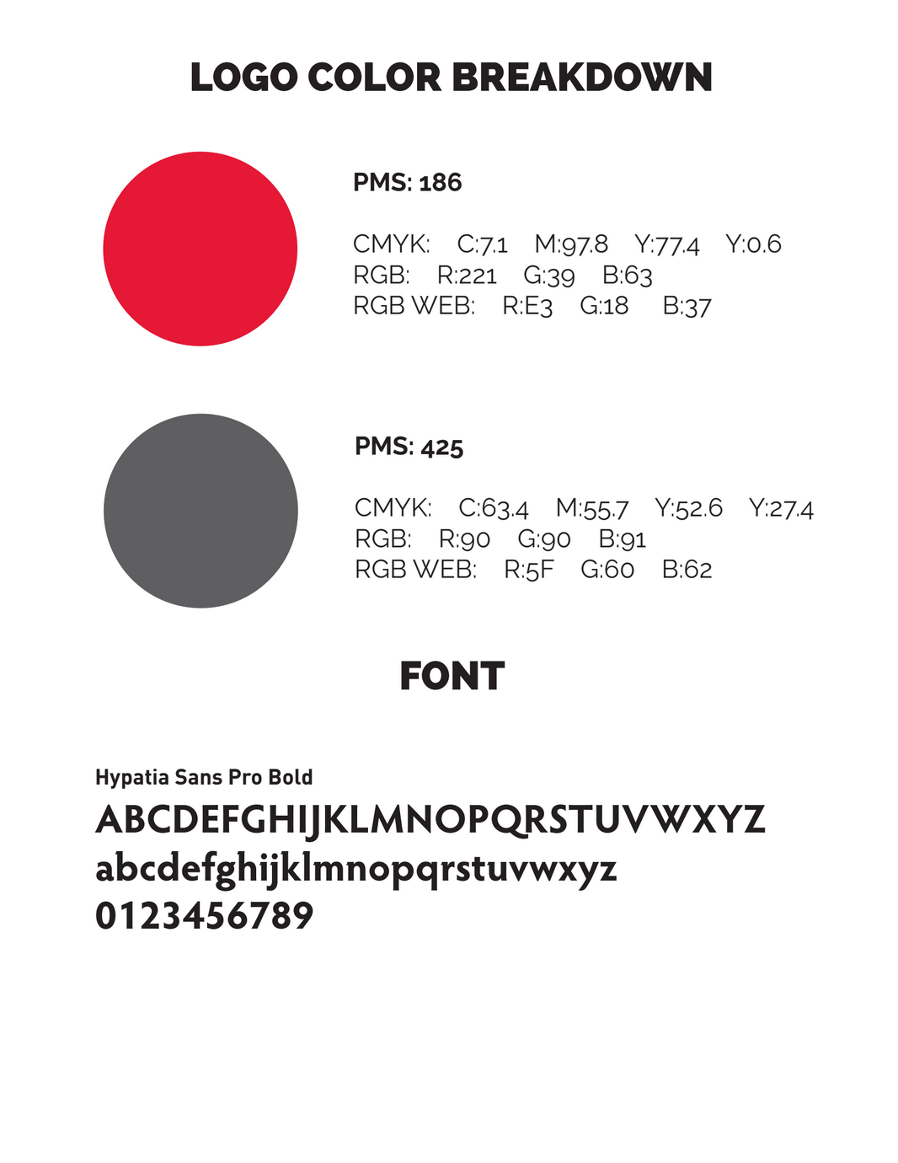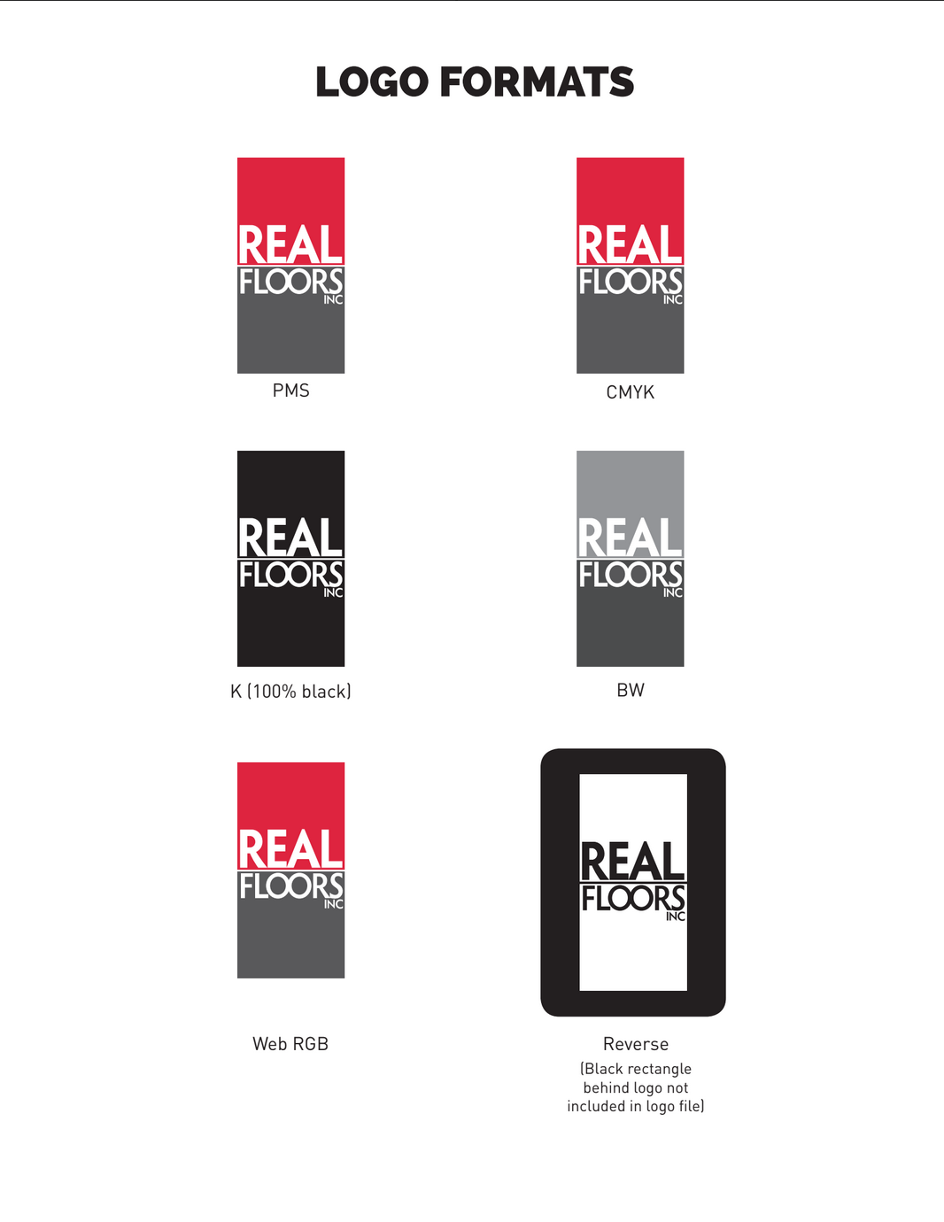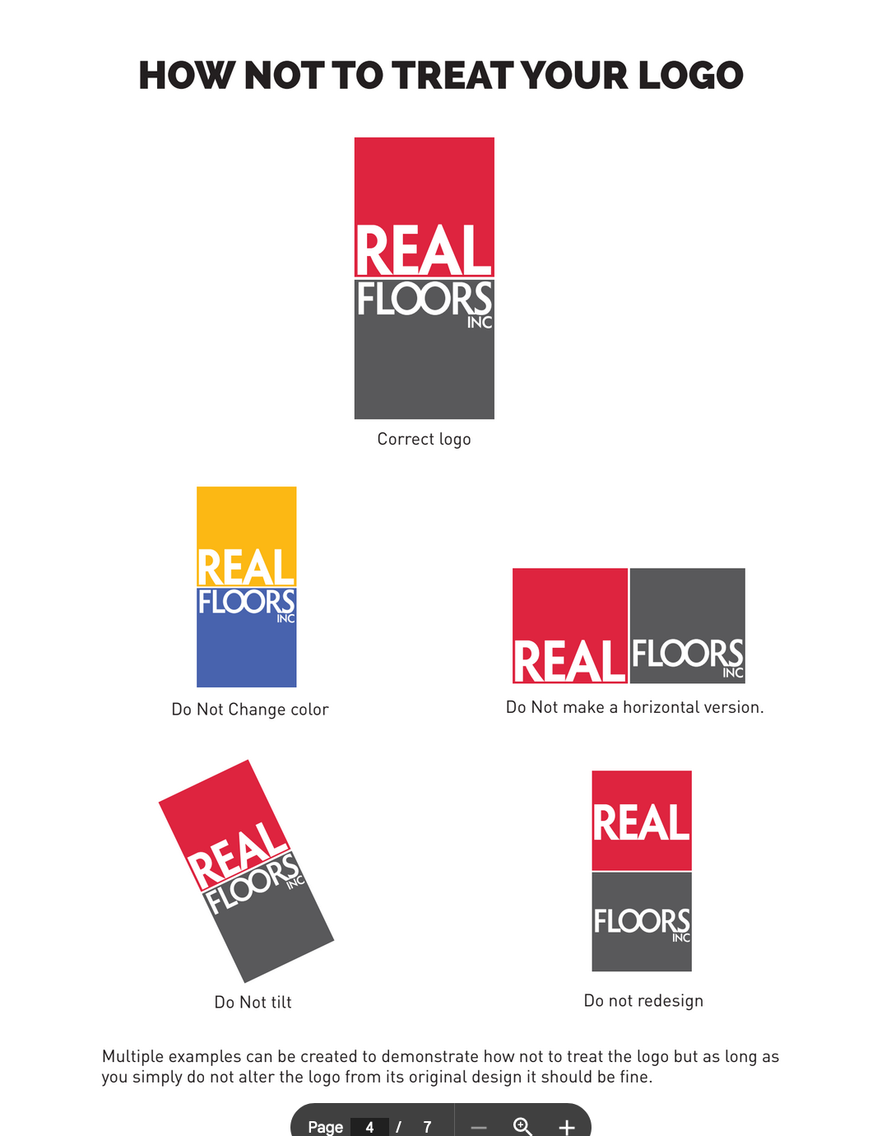

*Figure 1. Examples of pre-existing branding guidelines.*

|  |
| --- |
|  |

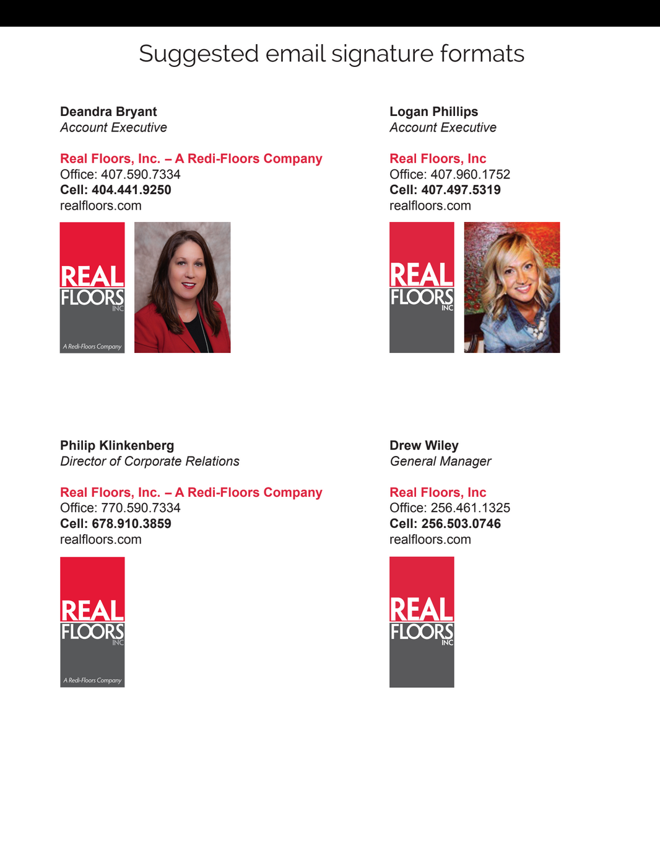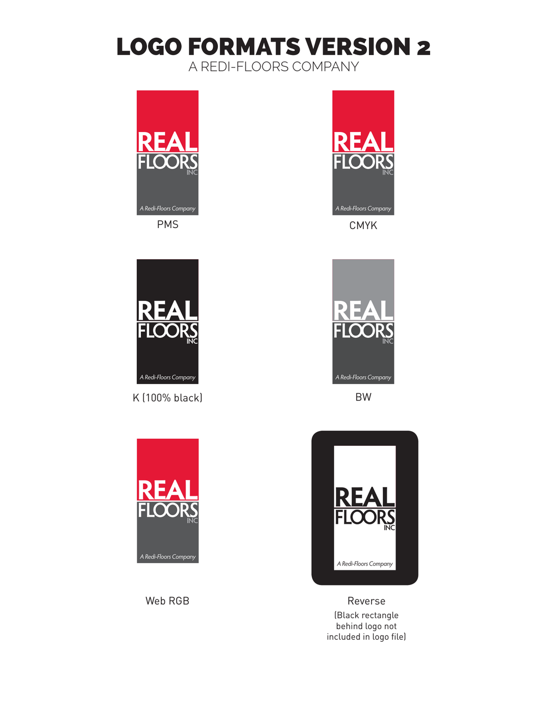

*Figure 2. Examples of incorrect branding in the pre-existing Branding Guidelines.*

In the Figure 2 examples above, the use of “Redi Floors” is no longer permitted in any branding. Additionally, the need arose to include photo, social media and communications guidelines in addition to the logo and color branding. The final deliverable can be found in Appendix A below.

## PMG Look Book

Part of the corporate sales process is assisting corporate customers in deciding which products will be on the list of approved specifications (or “on spec”) for their properties to use. During negotiations with one such management company (Property Management Group, or “PMG”), I was asked to create a look book comparing all the options they were considering, including both a page with images for direct side-by-side comparison of the products, and a “spec sheet” with details about each of the products being considered (seen in Figure 3 below).

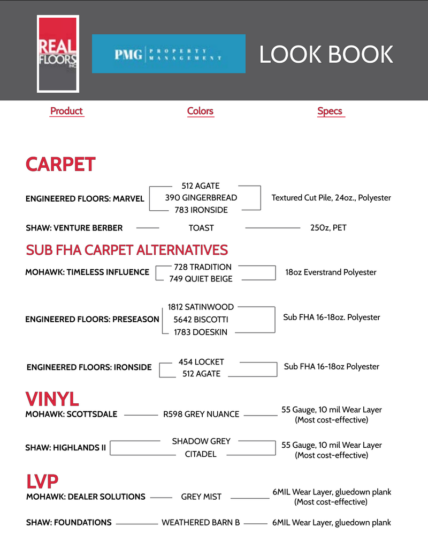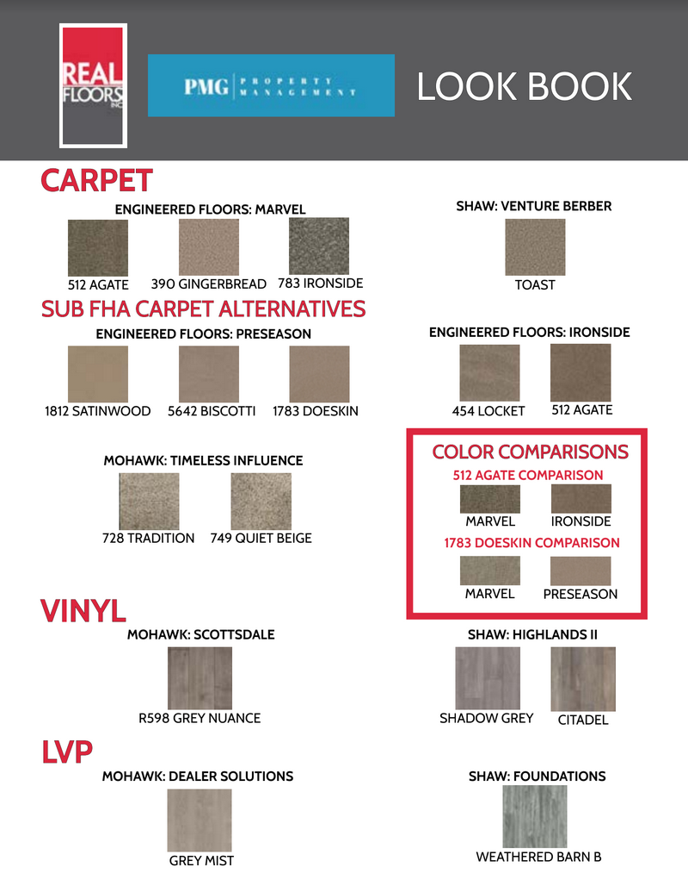

*Figure 3. PMG Look Book.*

## Corporate Price Sheets

Prior to my internship with Real Floors, corporate pricing was managed in Google spreadsheets. Data was manually entered, added and formatted by hand. Each management company has its own price sheet, set up in a grid pattern with products and labor lines listed down the side, and markets across the top (as seen in Figures 4 and 5 below). In order to improve the process, I implemented two key improvements.

*Figure 4. Old Price Sheet Designs.*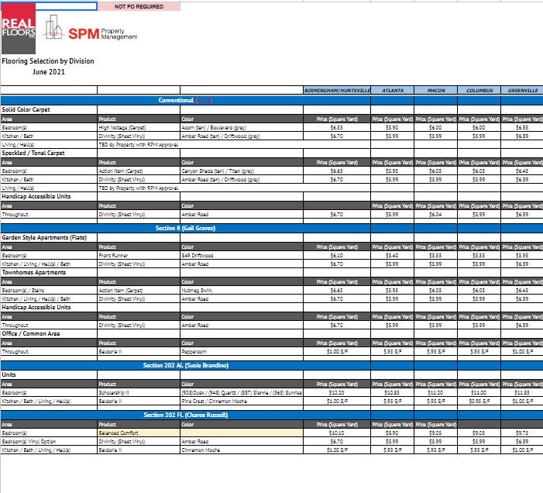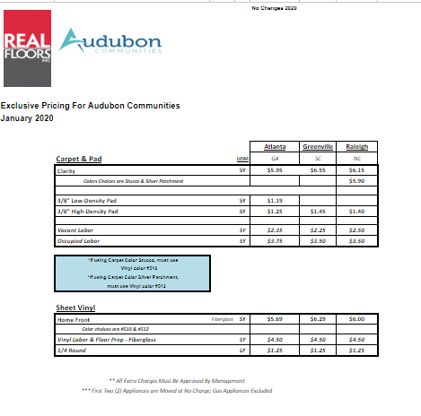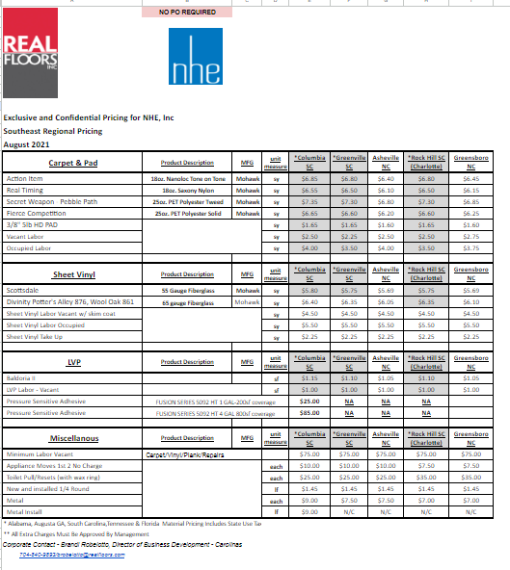

First, I standardized the formatting between all 80 of the corporate price sheets. As seen in Figure 4 above, there were numerous different styles, designs and formats throughout the different management companies. Because these sheets are also intended to be given to our customers in pdf format, I designed a version of the price sheets that were a cleaner, more readable design, while better showcasing the company branding by removing extraneous colors, especially those which did not align with the company style guide I made previously in the internship (See the Branding and Communications Style Guide section above).

I started by making a prototype that could be reviewed by the rest of the team (seen in Figure 5 below) before the design was implemented into all 80 corporate price sheets.

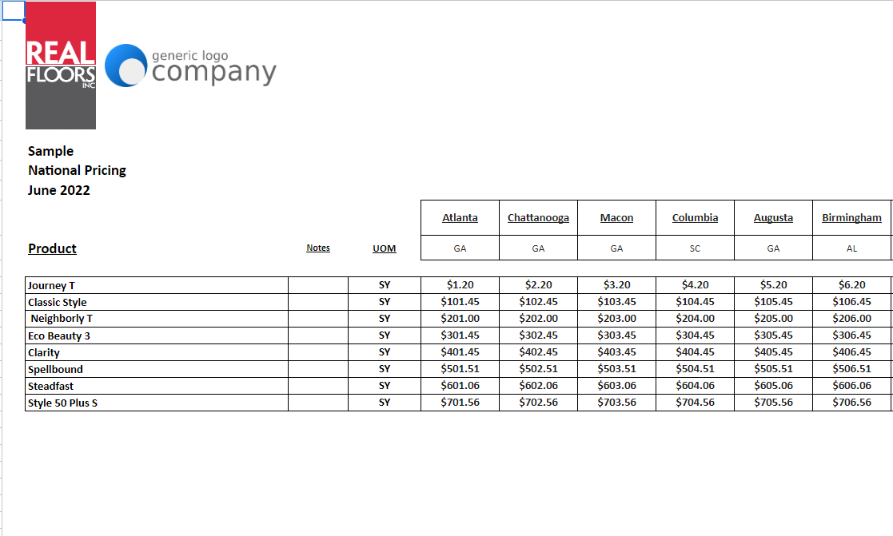

*Figure 5. New Price Sheet Design Prototype.*

The second step was to add formulas in order to both decrease errors and improve the usability of the sheet. Each sheet has two parts: The final sheets (seen in Figures 4 and 5 above), and the worksheets (seen in Figure 6 below).

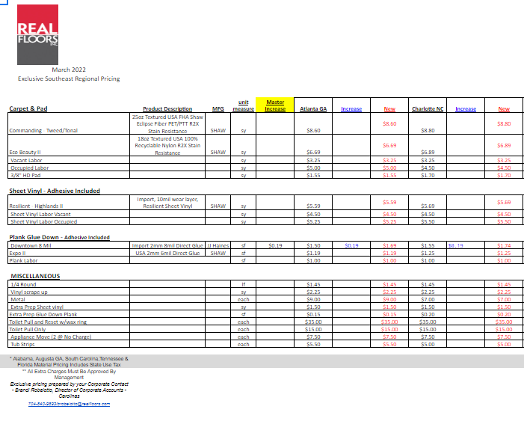

*Figure 6. Price Sheet Worksheet.*

The worksheets are meant for internal use. Each market or branch is comprised of three columns: the old price, the change in price, and the new price. Prior to this project, each column and the final sheet were all manually maintained. The requirements for this stage were two-fold: decrease the number of columns that needed to be edited to reduce the risk of error, and it had to be something that could be teachable, so others could learn how to manage the formulas.

I created several possible series of formulas; however, I ultimately decided to utilize a VLOOKUP. I chose VLOOKUP because it could consistently be used in the most places compared to other potential formulas (such as an index-match-match or query sort), meaning that if someone did need to learn how to manage these formulas with a lower basis of excel/sheets experience, they would only need to learn one formula, rather than multiple.

As such I used the VLOOKUP in three ways:

1. To pull the pricing into the “old” column on the worksheet from the previous final sheet
2. To pull the increase amount for each product from a separate master increase amount sheet
3. To pull the pricing from the “new” column into the new final sheet

These formulas allow the sheets to be edited much more quickly, as changes only need to be made in one place, and the formulas would automatically populate the pricing into the correct sheets. The final formulas can be seen in the job aids below.

## Price Sheet Formula Job Aid

Along with the price sheet redesign, I also created two sets of job aids to help my coworkers be able to utilize and recreate the redesigned price sheets.

The first set of job aids was designed to help with formatting the new price sheets and worksheets. Those job aids can be seen in Figures 7 and 8 below.

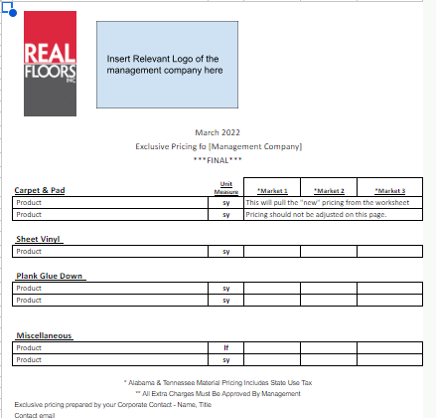

*Figure 7. Final Price Sheet Job Aid.*

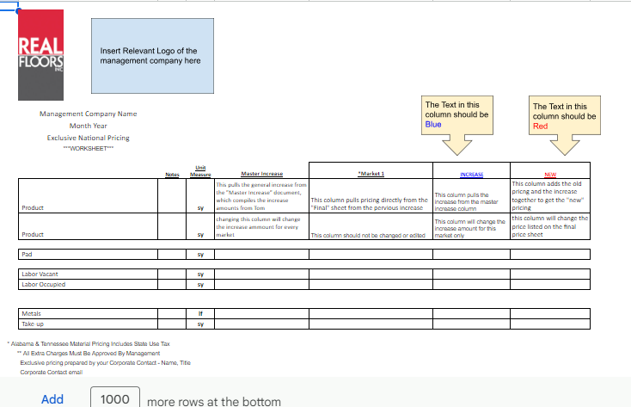

*Figure 8. Price Sheet Worksheet Job Aid.*

The second set of job aids I created were for the formulas. These were intended to also act as a guide for someone if I was unable to be there to train them, potentially with minimal excel experience. As such, I made sure that not only were the formulas included in these job aids, but also explanations for what information needed to be entered into each part of the formula.

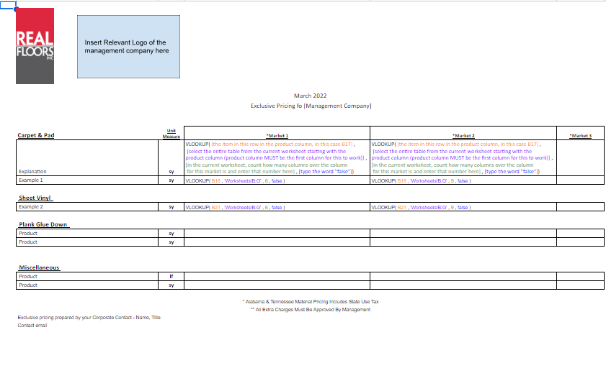

*Figure 9. Final Price Sheet Formulas Job Aid.*



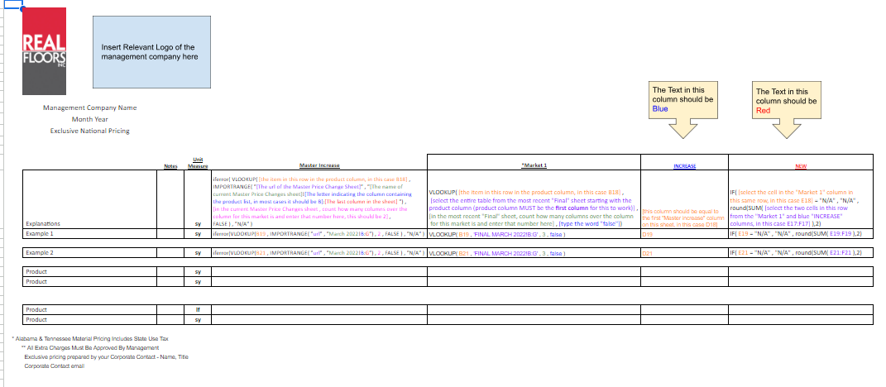

*Figure 10. Price Sheet Worksheet Formulas Job Aid.*

# Analysis

## Learning Objectives

Overall, I think I was highly successful in completing the learning objectives from this internship. At the start of the internship, my manager and I developed the following three learning objectives:

* At the end of the internship, Danielle will be able to design and implement processes to help improve the corporate price sheets.
* At the end of this internship, Danielle will be able to create job aids to assist in training others on any systems she designs and implements.
* At the end of the internship, Danielle will be able to create digital materials used in communication with customers.

I feel that I was not only able to succeed in meeting the expectations of those objectives but exceed those expectations. For example, I was able to not only provide the job aids and redesigned price sheets, but also was given the opportunity to train my coworkers on how to use them. Additionally, I not only provided a piece of marketing material in the form of the look book but was able to also create the Branding and Communication Style Guide for future marketing materials moving forward.

## Overall Performance

Overall, I think I was able to complete the projects exceedingly well. One thing I struggled with the most was the level of detail needed for this position. In school, I have been used to compiling full reports and very formal presentations of my work, and that’s not what they were looking for. I found myself putting a lot of effort into making formal reports when I didn’t have to.

## Personal Observations

### Metacommunication

Overall, I felt like direct, one-on-one communication is really good at Real Floors. Almost all of my coworkers are excellent communicators. Most of our team works in sales, so communicating is one of the stronger skillsets seen throughout our team. However, because of the nature of what we do, we often have to communicate outside the team as well.

Oftentimes the communication breaks down when there is information that needs to be disseminated throughout the rest of the company. In July 2022, Real Floors merged with Arbor Contract Carpet, based out of Denver, CO. The two halves of the company communicate in very different ways and have very different cultures surrounding communication, so it has been a hard adjustment throughout this past year, including during my internship period. I think there needs to be a lot of metacommunication that touches on things that haven’t yet been discussed (e.g. not just what platform will be used, but how that platform will be used and what the expectations are for everyone using that platform).

### Work Environment

I worked in the corporate headquarters in Marietta, GA, with the opportunity to work from home occasionally. I found that working in the office has been a wonderful experience and I greatly preferred it to working at home. This was because the social value of getting to work with my teammates and coworkers outweighed much of the convenience of working at home.

Additionally, Real Floors’ corporate office recently moved to a new building in January, so I have enjoyed the opportunity to work in such a new space with the ability to customize my cubicle area. For example, there are painted signs with our names that you can get in tourist areas, and it turns out that me, my coworker and one of my bosses all had one of our names so we all hung them above our desks. This was a fun little personal touch that really helped me feel welcome and a part of the team.

The main downside I experienced was the commute. I unfortunately had an hour commute in the mornings, and this was probably the worst part of this position. I can manage it but I know in the future that it is not as feasible/manageable of a commute as I had originally thought it would be.

### Managerial Support

One thing that I was exceptionally grateful for during this internship was the support of both my direct supervisor as well as upper management. I was given a lot of opportunity to present my ideas and was afforded the trust to implement them right from the start. The management has always been exemplary representations of this company’s core values (Integrity, Mutual Respect, Work Ethic, Family, and Customer Service). The executive management has been extremely inviting and immediately took the opportunity to invite me to use the skills I learned through my degree program.

Additionally, they really exemplified those core values outside of just professional obligation. For example, at one point during my internship my car engine failed while I was on my way to work. Despite being over an hour away from the office, multiple people, including members of executive management, offered to come pick me up and went out of their way to ask if I was ok and if there was anything they could do to help.

# Department Recommendations

Following my internship period at Real Floors, I have developed two detailed recommendations for the Mercer Technical Communications department.

## Varied Job Roles

One thing I have always appreciated about the Mercer TCO program is how group projects are managed. Not only allowing but encouraging students to set boundaries, expectations and courses of action for repercussions should a member not fulfill those expectations.

That being said, most projects at Mercer encourage students to work on projects as equals, with very few exceptions such as the TCO 250 Communication in Management course. In that course, students take on a role as either a team leader, or a team member under that leader. While I think this is an excellent opportunity, I think it only gives an opportunity to work on one side of that power dynamic within a project group. It would be a very helpful opportunity for students to be able to experience multiple sides of that dynamic within a group.

## Open-Ended Deliverables

While at Mercer, a lot of projects, understandably, are designed to encourage students to design a specific type of deliverable; however, during my internship I found myself being presented with problems that I had to find the best solution for. At Mercer, projects were presented as “Design this specific type of deliverable” whereas in the workplace it's more of a situation where I was expected to come up with the best solution to a problem and figure out which type of deliverable would best help solve the problem.

Mercer’s TCO program does touch on that skill, however I think that placing a heavier emphasis on it by presenting projects that are more open ended and allow students to choose which type of deliverable would best fit would be extremely beneficial to help prepare students for the workplace.

# Final Reflections

## Moving Forward

So far, I have really enjoyed my time at Real Floors. Beyond this internship I have a permanent full-time position with the company, and I have greatly enjoyed every second of it. I feel like taking on these projects during the internship portion of my time here has really allowed me to expand my wings so to speak and venture into some parts of the company that I don’t usually get to work in and has allowed me to expand the opportunities to help my team in different ways.

During my time at Mercer, I primarily focused on UX research and design, and while that is ultimately a field I do enjoy and would like to potentially work in some day, I do feel like this position has shown me how to utilize my technical communications skills in a lot of different areas than I thought I would be, which I greatly enjoyed. I feel like utilizing some of those skills that I don’t typically utilize helped me improve those skills greatly.

# Appendix A. Branding and Communications Style Guide.

